**CONNECTIONS WHILE UPLOADING THE CODE**

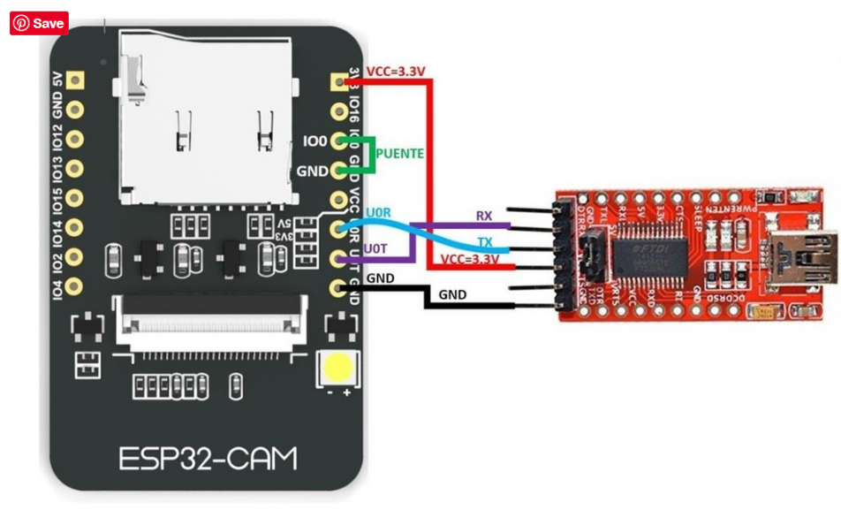

**CONNECTIONS AFTER UPLOADING THE CODE**

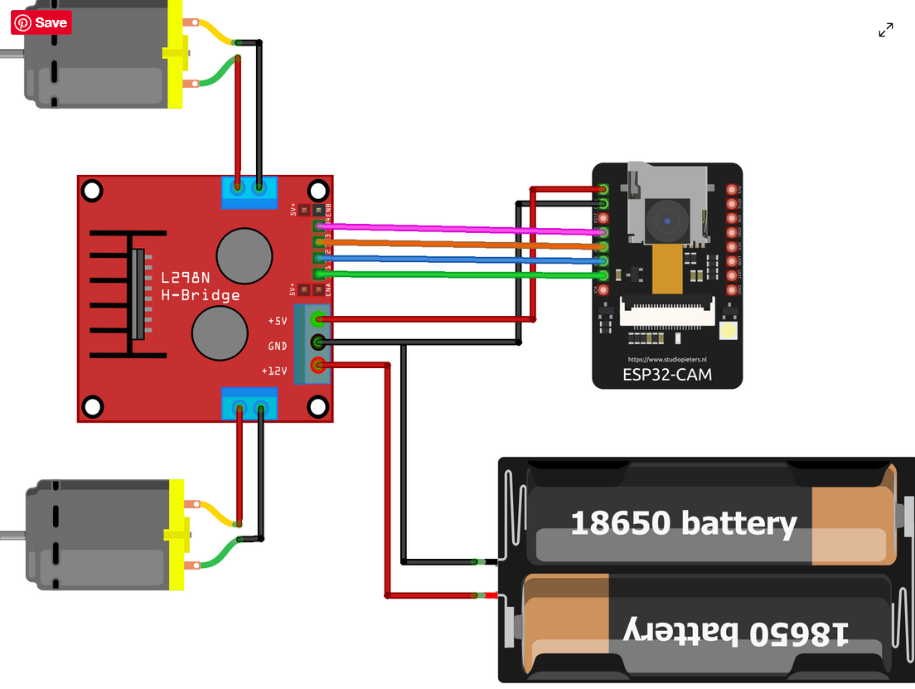

**CODE :**

https://github.com/mithun-srinivas/SPHERICAL-BOT.git